

Name : Yogesh Dinesh Joshi
Sap id : 590025632
Batch : 34
Teacher : Sugandha Sharma

Python Programming : Experiment 3

Objective 1 : Find a factorial of given number
Code : 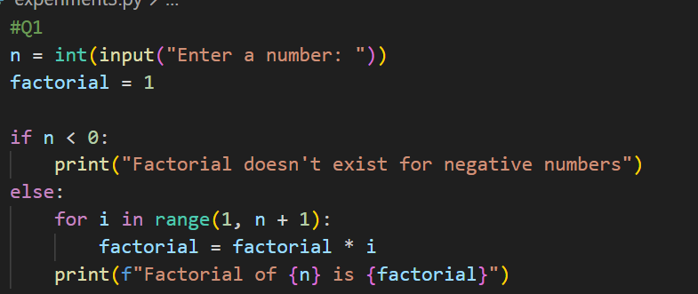
Output : 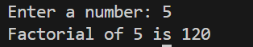

Objective 2: Find whether the given number is Armstrong number.
Code: 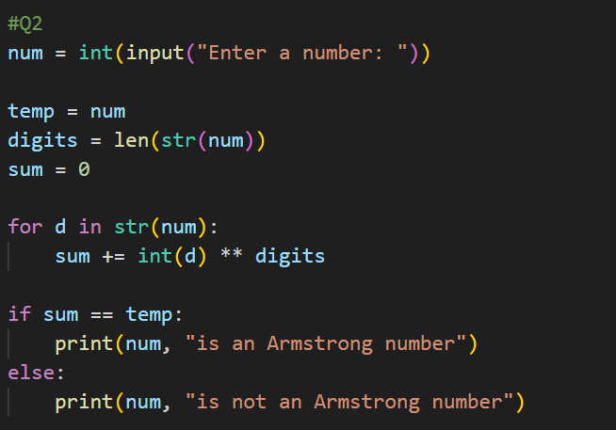
Output : 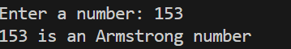
Objective 3 : Print Fibonacci series up to given term.
Code : 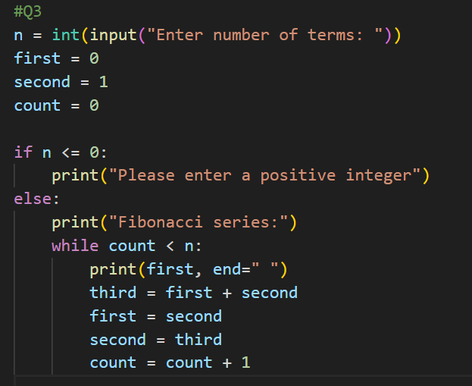
Output : 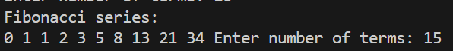

Objective 4 : Write a program to find if given number is prime number or not.
Code : 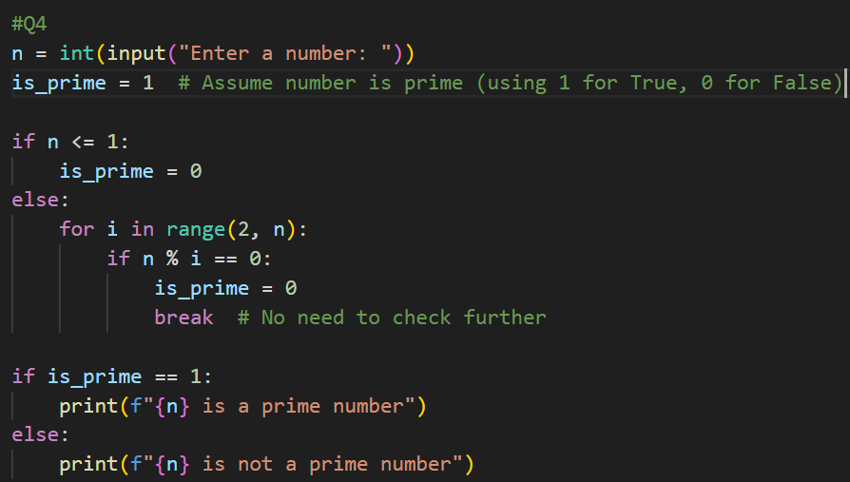
Output : 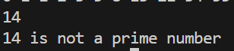

Objective 5 : Check whether given number is palindrome or not.
Code : 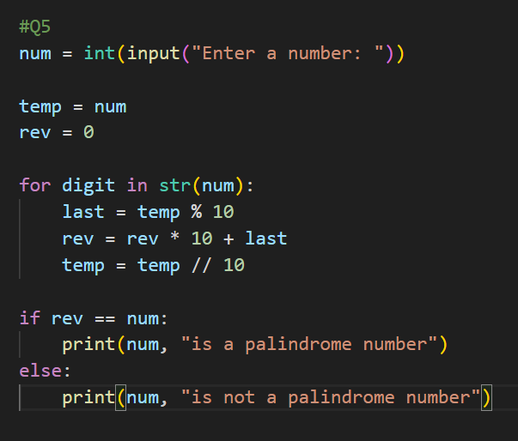
Output : 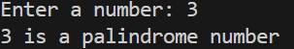

Objective 6: Write a program to print sum of digits
Code : 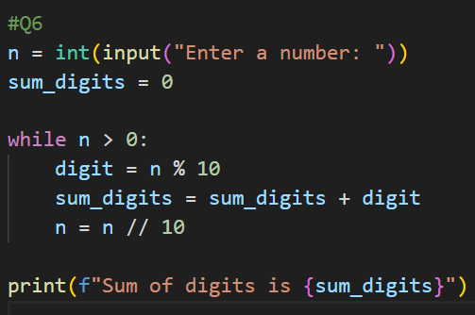
Output : 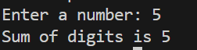
Objective : Count and print all numbers divisible by 5 or 7 between 1 to 100.
Code : 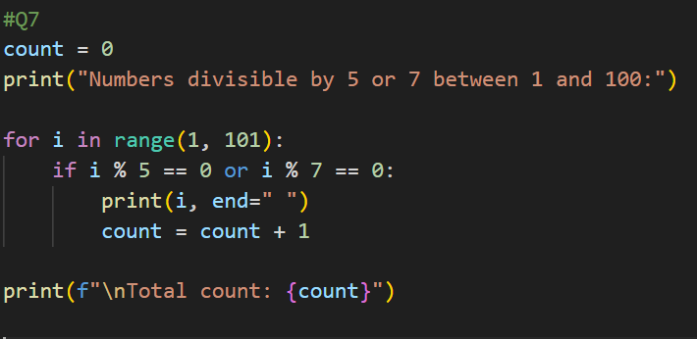
Output :

Objective 8 : Convert all lower cases to upper case in a string.

Code :
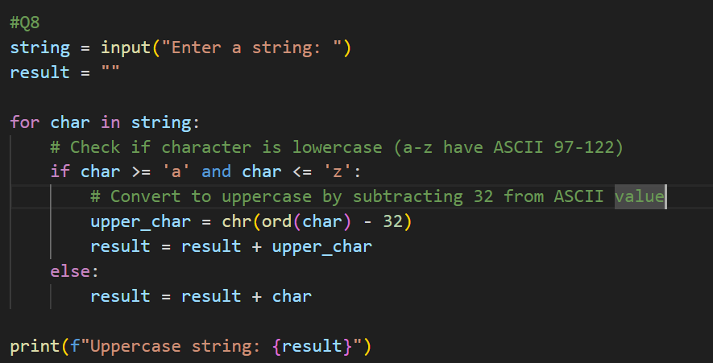
Output : 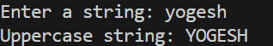

Objective 9 : Print the table for a given number:
5 * 1 = 5
5 * 2 = 10
Code : 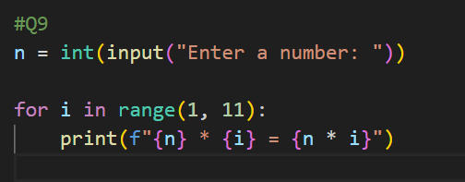
Output : 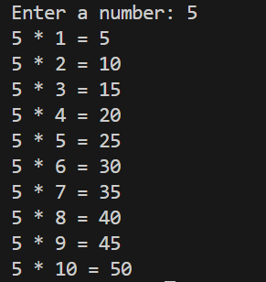

Objective 10 : Write a program to print the following pattern
123454321
1234 *4321
123 * * 321
12 * * * 21
1 * * * * 1

Code : 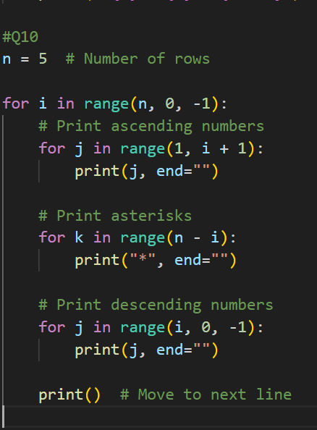
Output : 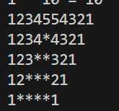

Objective 11 : Write a program to print the sum of the following series
1+ ½ + 1/3 + ¼ +….+1/n
Code : 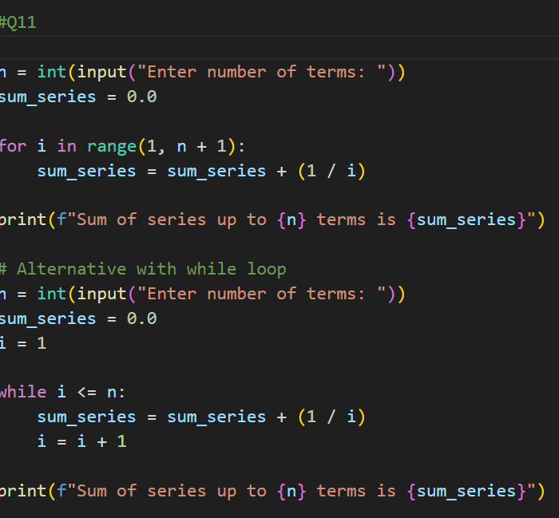
Output :

